User manual

This online appointment website is a user-friendly platform for rural students and academic professionals in science. The site provides useful functionality and features so that students and scientists can manage their appointments in an easy way.

This manual shows the main features and functions of the site and explains the many ways in which to use the site in order to get the most use of the resources.

Content

Main functions - student 3

1 Search: 3

1.1 Quick search 3

1.2 Advanced search 3

2 Book appointments 4

3 Manage appointments 6

3.1 Manage current appointments 6

3.2 View history appointments 6

4 Manage account information 7

4.1 Update personal information 7

4.2 Update password 8

***Main functions - scientist………………………………………………………………………………………………….9***

**1 Manage Timetable**………………………………………………………………………………………………………**9**

1.1  Add Timetable 9

1.2 Manage Current Timetable 10

2 Manage appointments 10

3.1 Manage current appointments 11

3.2 View history appointments 11

4 Manage account information 11

4.1 Update personal information 12

4.2 Update password 12

# Main functions - student

## Search:

* Search function is shown on the student’s home page. The site allows users to search for scientists by two ways: quick search, advanced search.

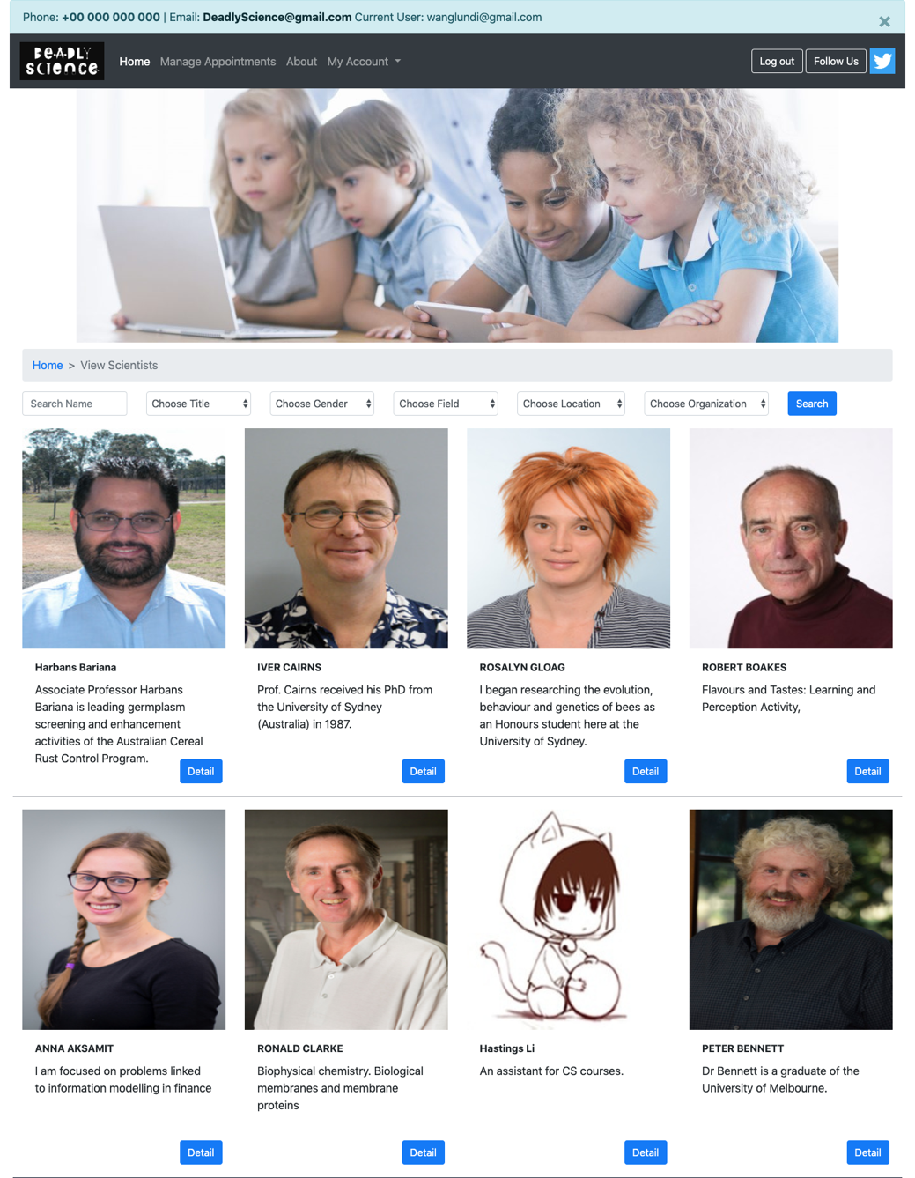

Search field



### Quick search

Quick search bar

* Quick search retrieves relevant results based on the keywords that users enter into the search field.



### Advanced search

* Advanced search allows users to narrow down the range with specified requirements including: Title, Gender, Specialty, Location, Organisation.



Advanced search:

Use filtering options from drop-down boxes

## Book appointments

* Step 1: click “detail” button to enter a scientist’s profile page. This will bring users to the personal page of the scientist.

The profile page shows a scientist’s detailed personal information including title, specialty, location, organisation, profile image, and personal statement. On the right side of the page, a timetable is displayed to show the availability of the scientist in terms of available time slots and meeting methods.



enter the scientist’s profile page field

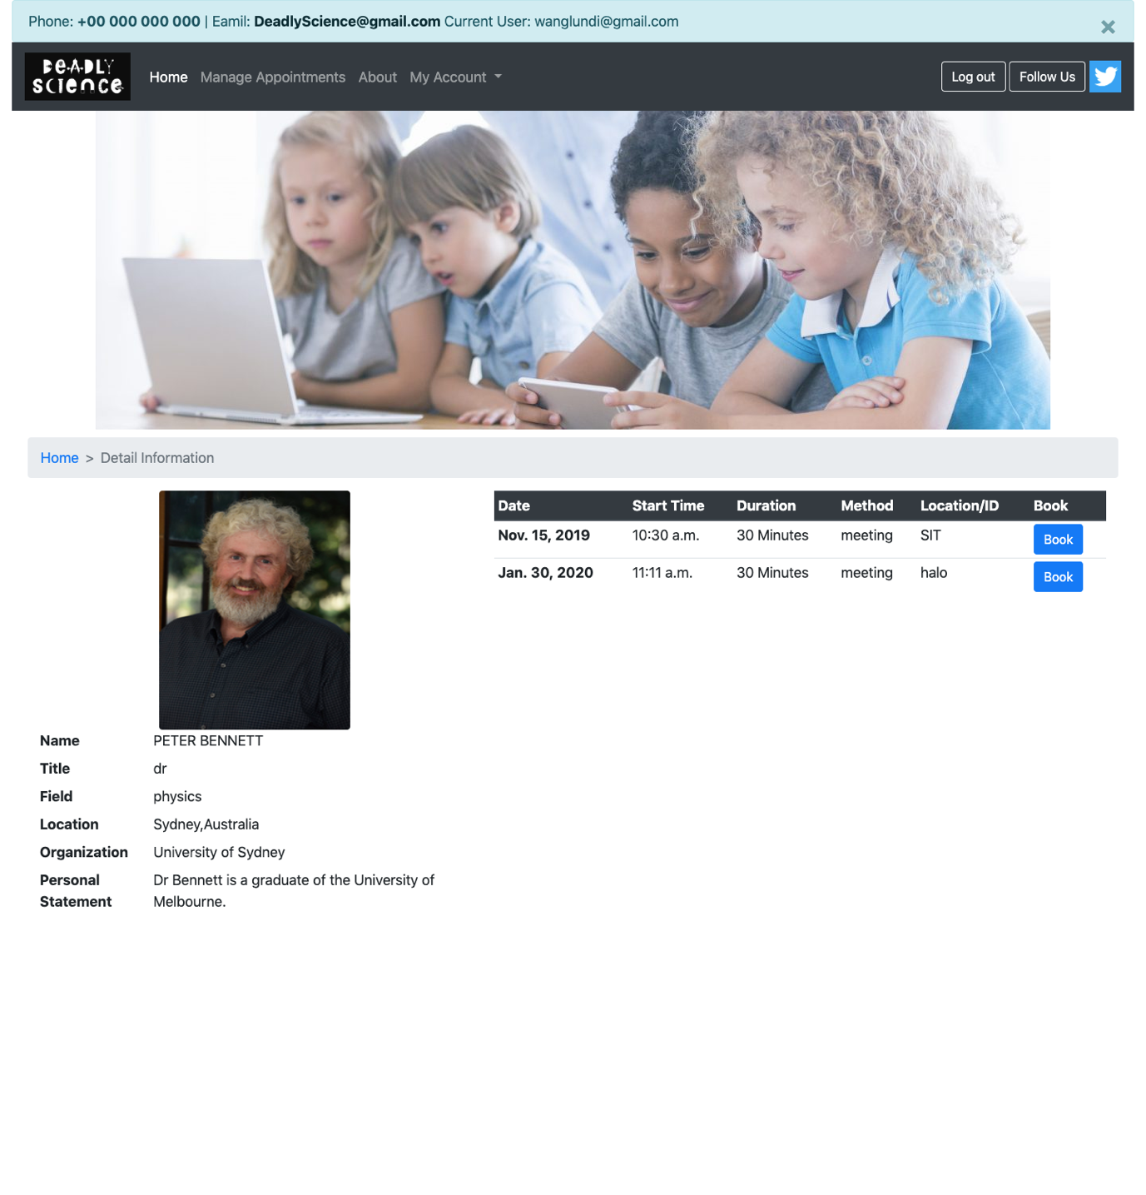

timetable

personal information

* Step 2: click “Book” button once the user decides which time to book. This appointment will then be shown on the scientist’s page.



book an appointment

## Manage appointments

* click “Manage Appointments” button in the navigation bar on the top of the page to enter the appointment management page.

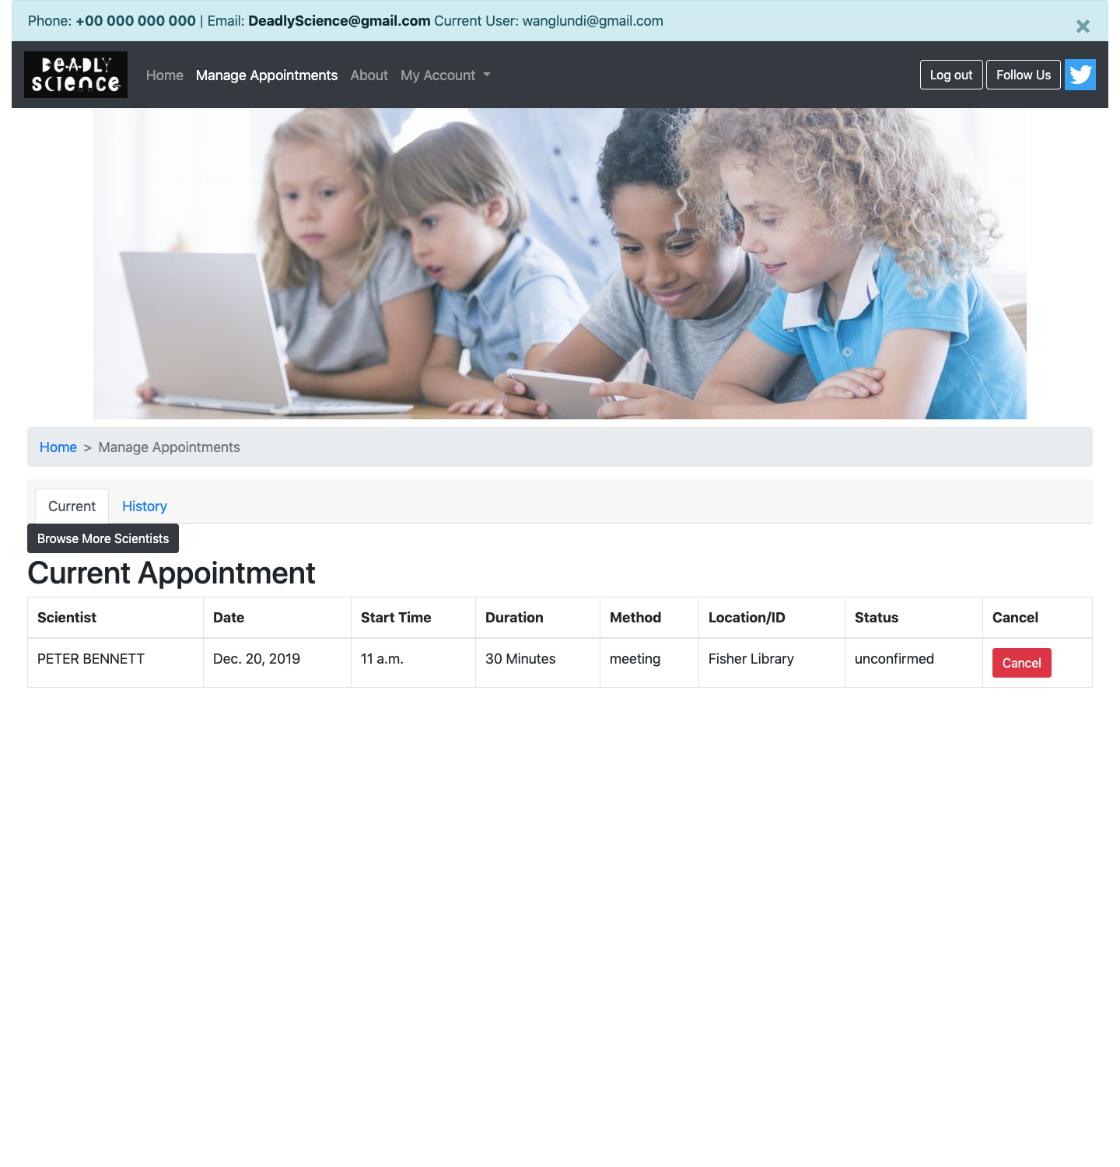

### Manage current appointments

* + click “Cancel” button to cancel an appointment.

cancel an appointment

### View history appointments

* + click “History” button on the menu bar to show the detail information of history appointments.

view history appointments

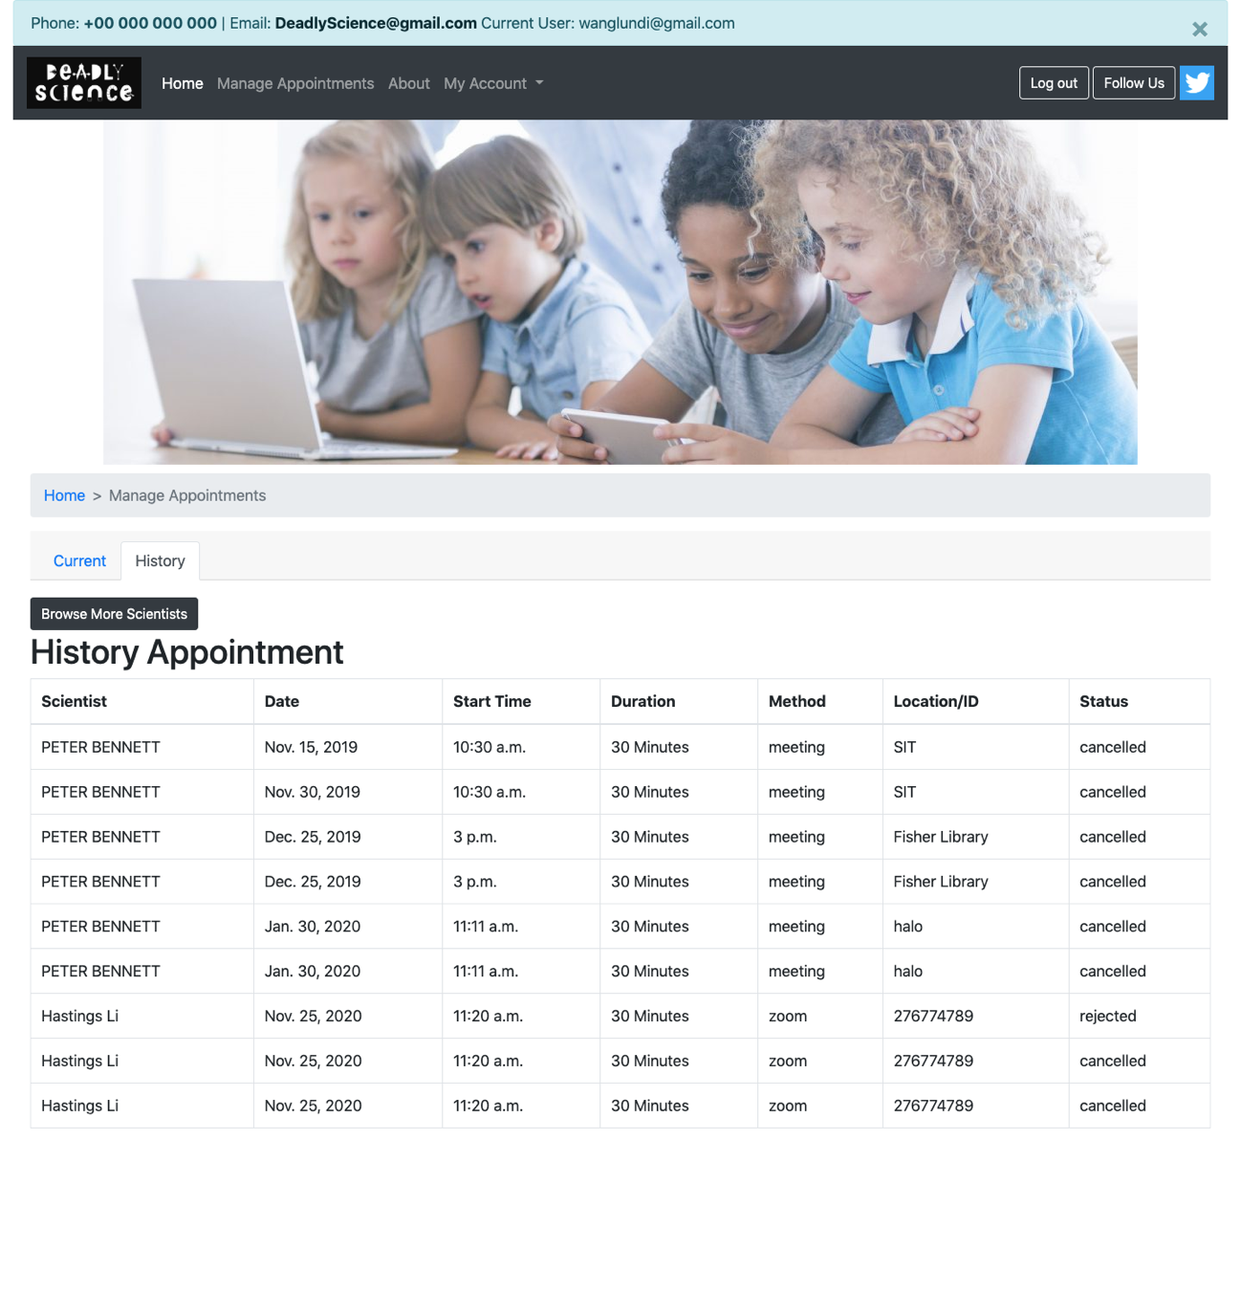

## Manage account information

* click “My Account” button in the navigation bar on the top of the page to enter the account management module. This module supports two functions: personal information update, login password update.

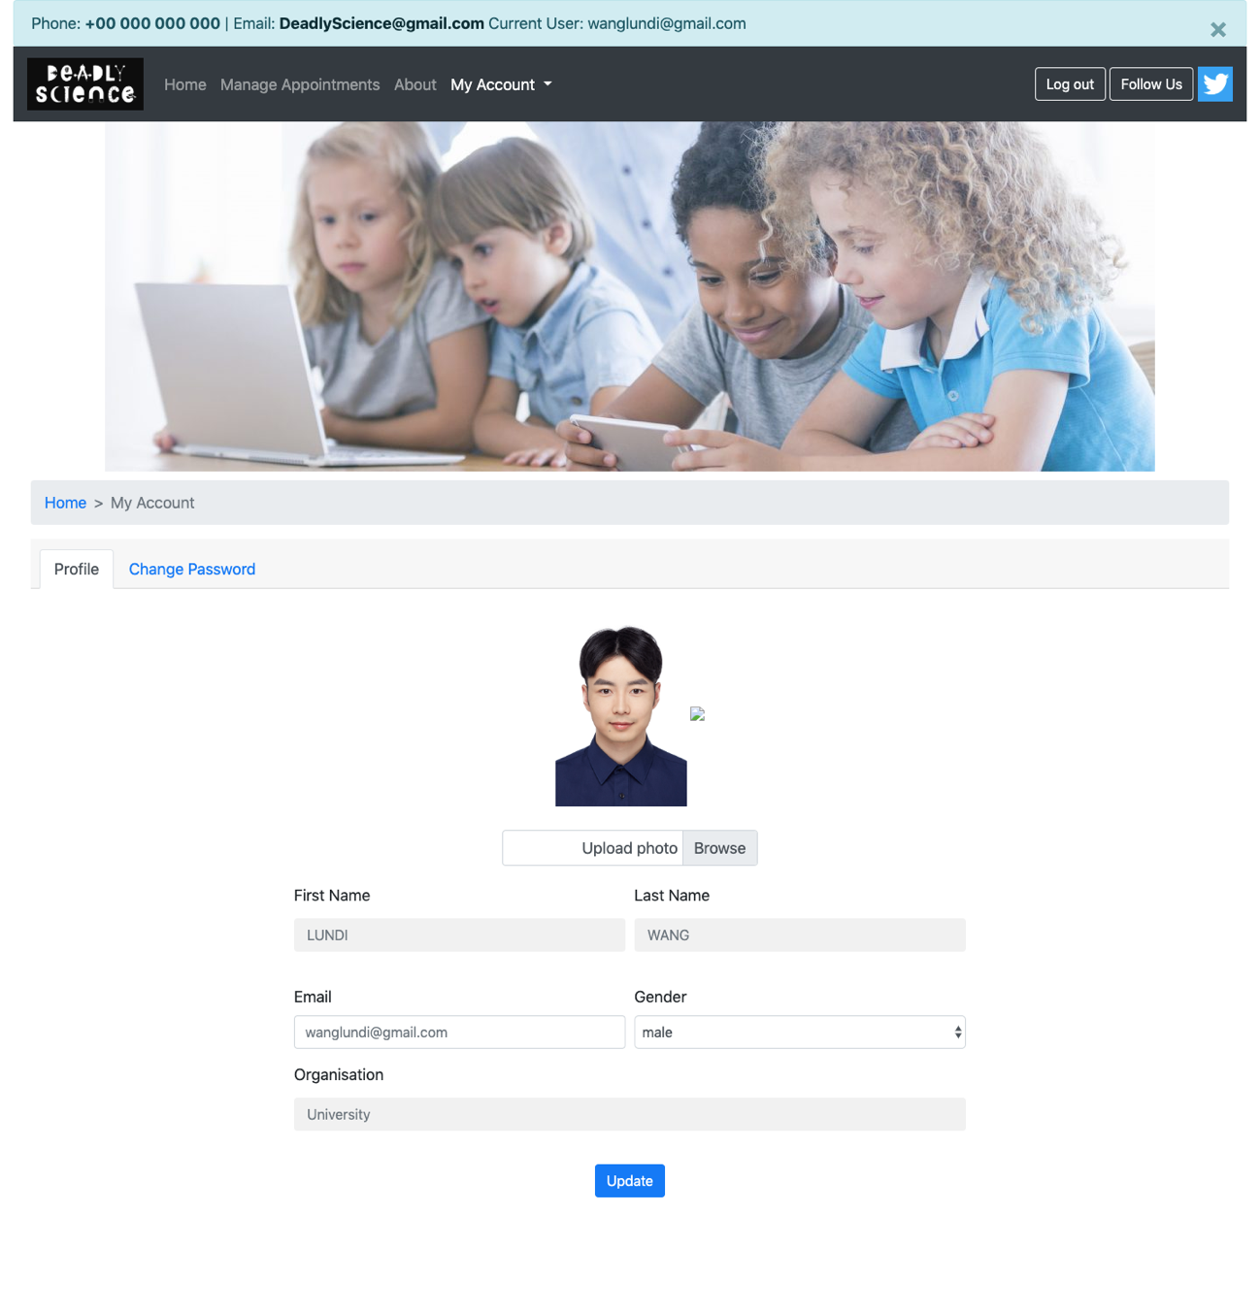

### Update personal information

* + Step 1: click “Profile” button in the drop-down box of “My Account” button. This will bring users to their profile page.

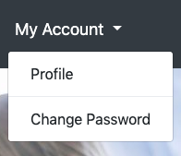

* + Step 2: update personal information including First Name, Last Name, Email, Gender, and Organisation. Users can also upload profile images from local folders.

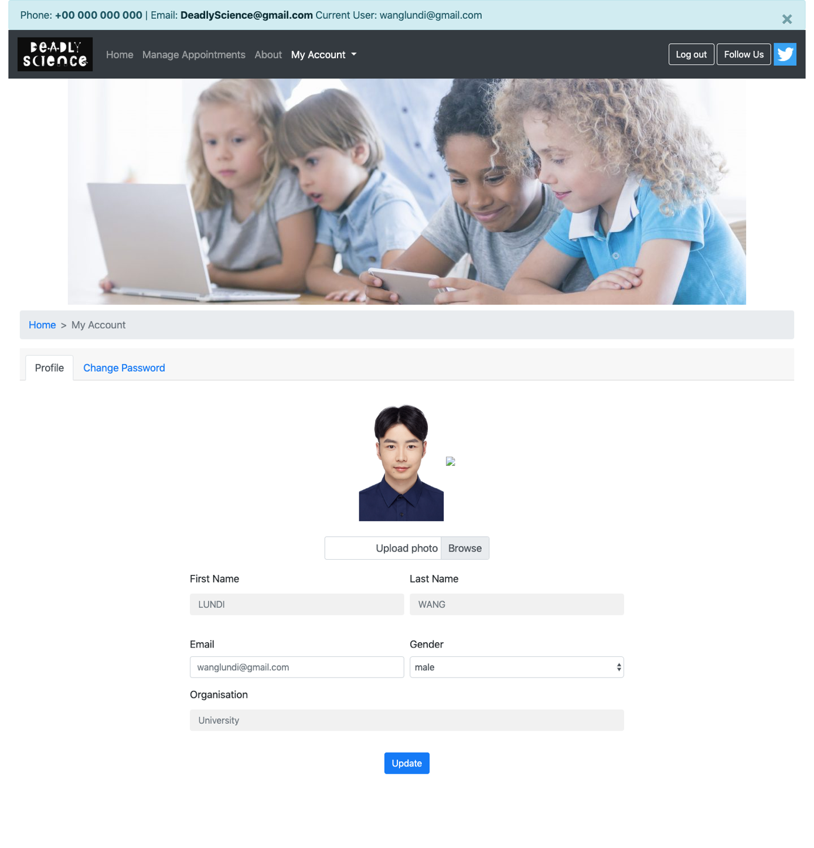

save change

view and update personal information

* + Step 3: click “Update” button to save the change.

### Update password

* + Step 1: click “Change Password” button in the drop-down box of “My Account” button. This will bring users to password update page.



* + Step 2: type in the new password in the input boxes.

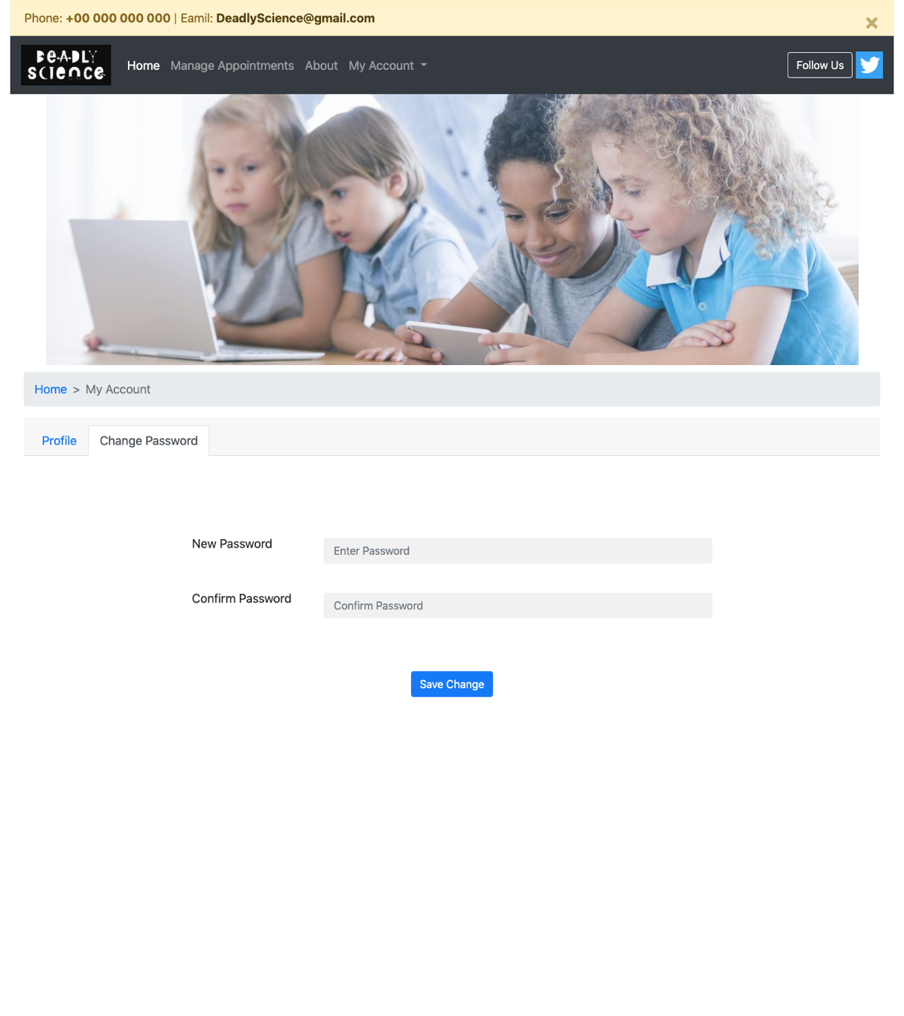

save change

enter new password

* + Step 2: click “Save Change”.

# Main functions – scientist

## Manage Timetable:

* After scientist login, the system will automatically jump to this page. The site allows scientists to add their new available timetable and manage current timetable.



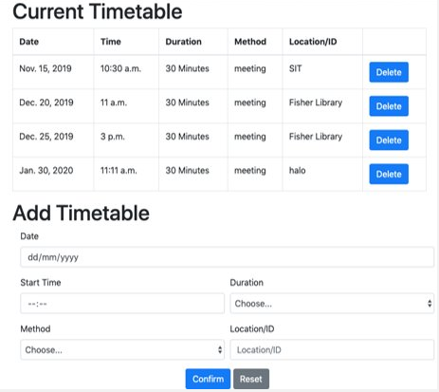

### 1.1 Add Timetable

* Step 1: Select and enter available schedule information including date, start time, duration, method, and location.

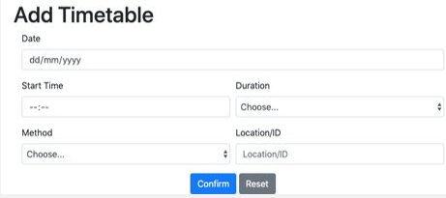

Confirm/Reset information

Add an information

of new available timetable

* Step 2: Click “confirm”. The information for this new timetable will be displayed in the Current timetable, and this information can also be found on the student's page.

Click “Reset” then the information will be cleared and the user can add it again.

### Manage Current Timetable

* This section shows the current timetable information. If the scientist wants to delete this schedule, click “Delete”

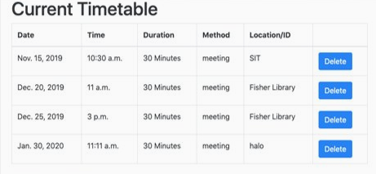

Delete a schedule

## Manage Appointment:

* click “Manage Appointments” button in the navigation bar on the top of the page to enter the appointment management page.



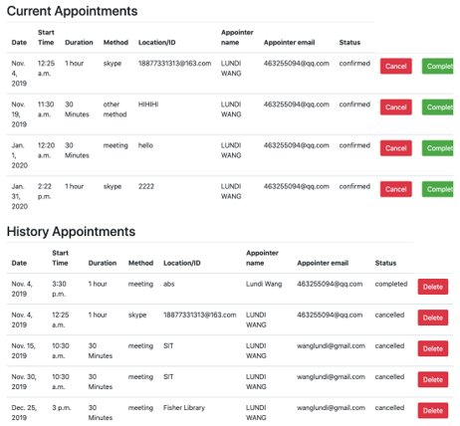

### Manage current Appointment

* Scientists can view the information of the appointment, including the name, contact details and needs of the person making the appointment. Scientists can click "Cancel" button to cancel an appointment. After the appointment is completed, the scientist can click the “Complete” button and this appointment information will be displayed in the History Appointments.

Complete an appointment

Cancel an appointment

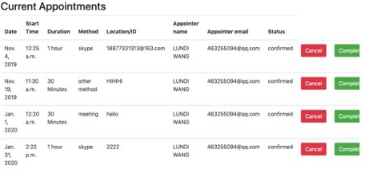

### 2.2 View Appointment History

* Scientists can view information about the appointment history in this section. They also can click “Delete” button to delete a history appointment.

Delete a history appointment

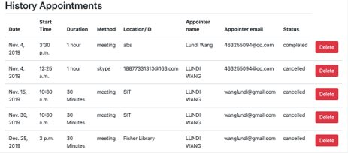



## Manage Account information:

* Click “My Account” button in the navigation bar on the top of the page to enter the account management module. This module supports two function, one is for users to update their personal information and the other is for users to update login password.



### Update personal information

* Step 1: Step 1: click “Profile” button in the drop-down box of “My Account” button. This will bring users to their profile page.



* Step 2: update personal information including First Name, Last Name, Email, Gender, Title, Field, Country, Location and Organisation. Users can also upload profile images from local folders.

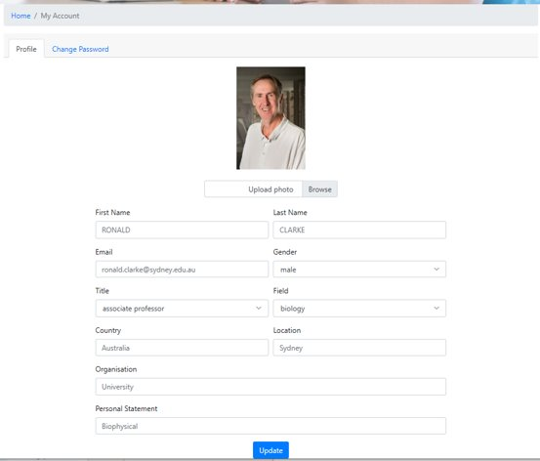

view and update personal information

save change

* Step 3: click “Update” button to save the change.

### Update password

* Step 1: click “Change Password” button in the drop-down box of “My Account” button. This will bring users to password update page.



* + Step 2: type in the new password in the input boxes.



save change

enter new password

* + Step 3: click “Save Change”.